Pack Hike 2024
L = Lion /T = Tiger /W = Wolf /B=Bear/ We=Webelos/ A= Arrow of Light

(We) Review the four points of BSA SAFE Checklist and how you will apply them on your 2-mile walk.

(B) Determine the fire danger rating along your path.

(We) Check the weather forecast for the time of your planned 2-mile walk.

(W/We) Identify appropriate/weather appropriate clothes and shoes for your walk/hike outside. Do your best to wear them on your walk.

(L/T/W/B/We) Identify the Cub Scout Six Essentials. Show what you do with each item.
(A)Learn about the Scout Basic Essentials.

(L/T/W/B) Learn about the buddy system and demonstrate how it works in the outdoors. Pick a buddy for your walk (could be your adult).

(L) What is S.A.W.

(T/We) learn & recite the Outdoor Code.

(W/B/We) Leave no trace principals – practice while on hike

(B) be kind to others on the path.

(L/T)20 min hike
(W) 30min hike
(B) 1 mile hike
(We) 2 mile hike

(B) Identify the location of your walk on a map and confirm your one-mile route.
(We) plan 2-mile route

(W) Using a map, locate where you live.
.
(W) Find the directions north, east, south, and west and the compass rose on a map.

(W) Find the directions north, east, south, and west using a compass.

(W) Practice using both a map and a compass.

(B) Make a plan for what you will do with your personal trash or trash you find along the trail.

(B) Learn about the path and surrounding area you will be walking on.

(L/T) identify things that you see that are natural and things that are manmade.

(B) Take pictures along your walk things that you want to remember on your walk.

(L/T/W) Identify common animals that are found where you live. Separate those animals into domesticated and wild.

(B) From a safe distance, identify as you look up, down, and around you, six signs of any mammals, birds, insects, reptiles.

(A) Select one of the animal and observe its behavior.

(T) Look for a tree where you live. Describe how this tree is helpful.

(A)Conduct a tree inventory. Select one tree.

(A)Determine if your tree is deciduous or evergreen.

(A)Determine if your tree is native or was introduced to your area.

(A)Find out how your tree deals with wildfire.

(A)Learn how wildlife uses your tree.

S.A.F.E.
Supervision
Youth are supervised by qualified and trustworthy adults who set the example for safety.
Assessment
Activities are assessed for risks during planning. Leaders have reviewed applicable program guidance or standards and
have verified the activity is not prohibited. Risk avoidance or mitigation is incorporated into the activity.
Fitness And Skill
Participants’ Annual Health and Medical Records are reviewed, and leaders have confirmed that prerequisite fitness and
skill levels exist for participants to take part safely.
Equipment and Environment
Safe and appropriately sized equipment, courses, camps, campsites, trails, or playing fields are used properly. Leaders
periodically check gear use and the environment for changing conditions that could affect safety.

S.A.W.
- Stay – Do not go looking or wandering around. When you get lost or separated your group or parents are likely to start looking for you in the last place, they saw you or at places you have been. If you stay where you are, chances are they will come back to that place to look for you.
- Answer – When you hear your name being called, answer back.
- Whistle – Use your whistle. Blow your whistle with three short blasts. Do this repeatedly until you are found.

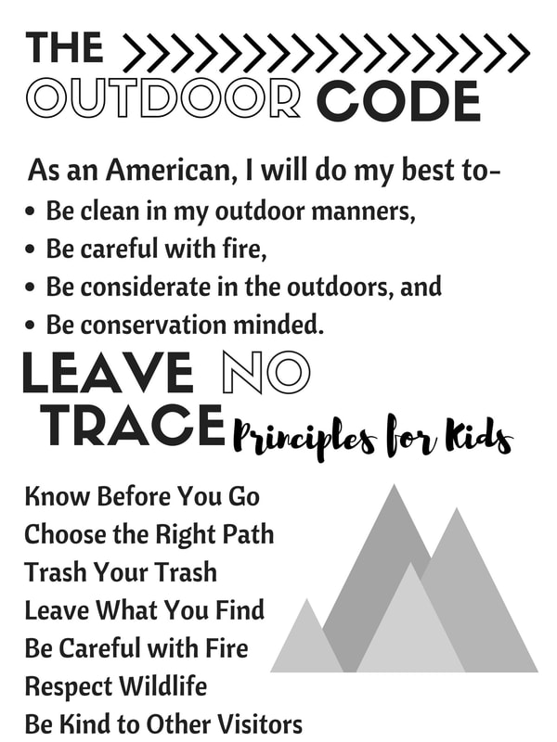
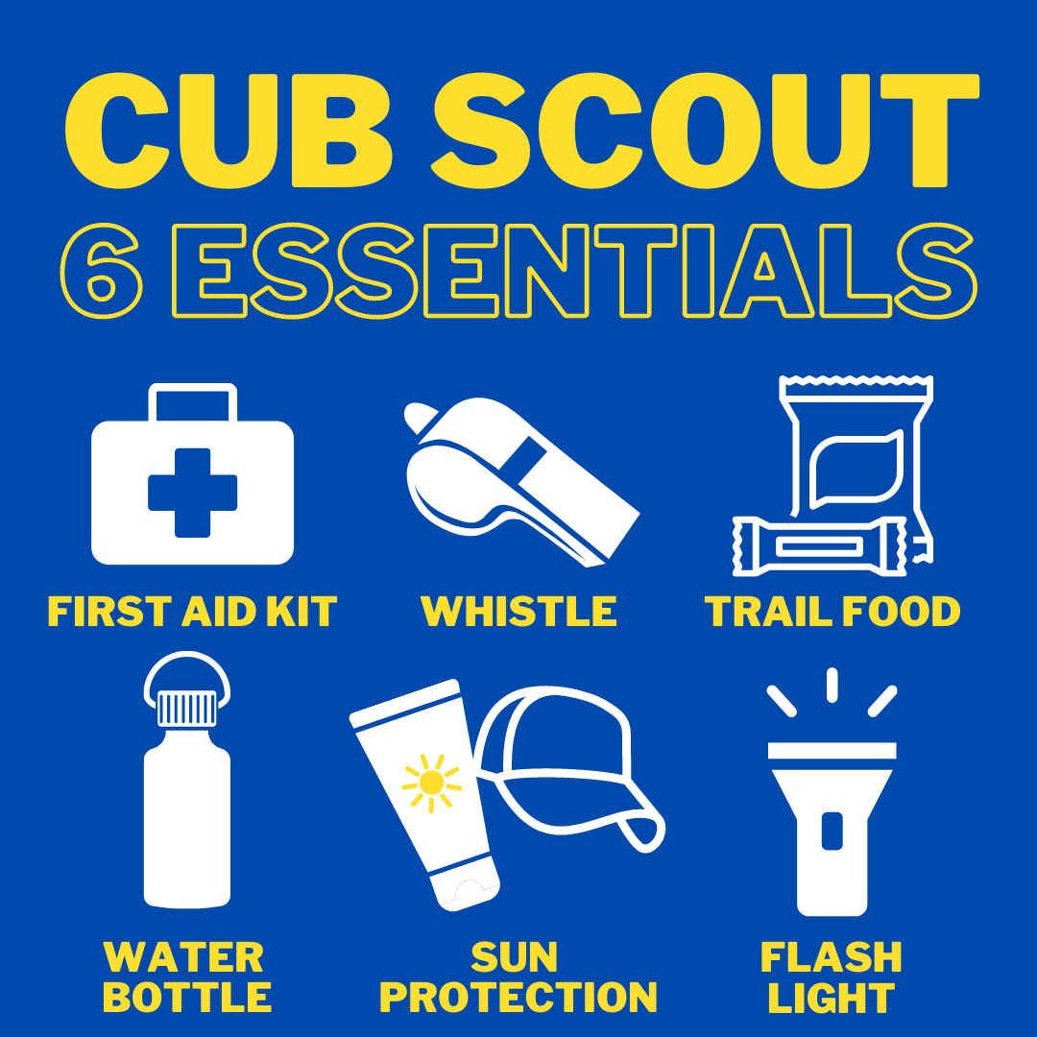

Scout Basic Essentials
- Pocketknife
- Rain Gear
- Trail Food
- Flashlight
- Extra clothing
- First-aid kit
- Sun protection
- Map and compass
- Matches and fire starters
- Water bottle
- Backpack

