Boy Scout
Christmas Wreaths
Total Wreaths Sold _________
Total Money received $_______
Scout Name: ______________________

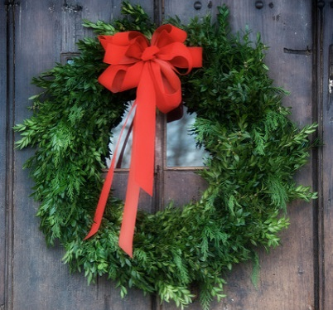
$25
$25

22” Beautiful Pine Wreath with Red Bow from Vaiuso's Farm
Christmas wreaths will be delivered around Thanksgiving weekend
Make checks payable to: Troop 633 /or Troop 1633/ or Pack 633
All payment is due at time of sale
RETURN FORM BY November 1st meeting
NAME | ADDRESS | PHONE | HOW MANY | AMOUNT | PAID
NAME | ADDRESS | PHONE | HOW MANY | AMOUNT | PAID

NAME | ADDRESS | PHONE | HOW MANY | AMOUNT | PAID

NAME | ADDRESS | PHONE | HOW MANY | AMOUNT | PAID

